***ABSTRACT***

***It is a website that serves and manages users interested in cars, especially those who are exposed to problems or malfunctions in the car. It allows users to display some car parts and cars that they want to sell and buy quickly and easily, it provides some petrol stations and mechanics to solve the holidays or the problem facing the user to reduce time and effort.***

***Table of Contents***

**1 INTRODUCTION** ....................................................................................................................11

1.1 Project description: ..................................................................................................................11

1.2 Project overview and objectives: ............................................................................................11

1.3 Targeted audience......................................................................................................................11

**2 SYSTEM ANALYSIS** .................................................................................................................12

2.1 System Requirements ..............................................................................................................12

2.1.1 Functional Requirement...............................................................................................13

2.1.2 Non Functional Requirement.......................................................................................13

2.2 Activity Diagrams .....................................................................................................................14

2.3 Use Case Diagram.....................................................................................................................17

2.3.1 Use Case Specification ..........................................................................................19

2.4 Conceptual Design ER Diagram.................................................................................26

2.5 Logical Design (Relational Schema) .......................................................................................28

**3 SYSTEM IMPLEMNTATION** ................................................................................................................29

3.1 Language used…………………………………………………………...…………………………30

3.2 Tools used ………………………………………………………………………………………...30

3.4 Screen Shoots for the System used ………………………………………………………………..30

**References**………………………………………………………………………………………………………34

***Table of figures***

Figure 1: Activity diagram for login and logout ........................................................................................15

Figure 2: Activity diagram for get services ................................................................................................16

Figure 3: use case diagram for ……………………………………………………………………...….18

Figure 4: ER diagram...................................................................................................................................27

Figure 5: Relational schema.........................................................................................................................28

**1- INTRODUCTION**

**1.1 Project Description**

It’s a website that manages the affairs of cars that provides the common services that you need, these services include: informing the user of vehicle matters that need to be followed up periodically, assistance with possible sudden malfunctions, and the ability for users to view and sell auto parts and communicate with each other.Due to the increase the use of cars nowadays for its importance in transportation, despite the fact that it reduces many problems, but it faces more problems, for this reason the site provides solutions.

**1.2 Project Overview and Objective**

This system is important and beneficial for everyone because it contains various services for vehicles and those interested in them, especially at the present time.

This system aims to make it easier for the user to manage vehicle matters that need to be checked periodically.

And to facilitate for the user how and how quickly to deal with the vehicle in the event of its breakdown so that it saves time in the process of searching for service providers and also provides the service of buying and selling to the user in an easier and faster way.

**1.3 Targeted audience**

The site targets those interested in cars, especially their owners, and all concerned parties that may obtain a profit from providing these services, such as mechanics, gas stations, maintenance shops and those interested in buying and selling auto parts

**2- SYSTEM ANALYSIS**

**2.1 System Requirements**

**2.1.1 Functional Requirement**

First, the administrator approves the creation of a user account, manages databases and gives the authority to companies that provide user services on the system and verify them.

the user logs into the website by entering his name and personal data, and then he has a special account on the website and enters again through it.

After logging in, the user will be able to enjoy the services of this site, which include:

First: A service that alerts the user to matters related to the periodic maintenance of the car, which is changing the windshield wipers, brakes, heating, and a steam blocker that must be checked before winter, as well as the engine, wheels, cables, and oil changes for each of the engines, Dirksion and gear.

Second: In cases of sudden car malfunction such as: a puncture of the tire, lack of gasoline or electricity and an accident occurs, in this case he can call the emergency numbers or communicate with a mechanic or a specific authority for transporting cars. If the user does not face any of these problems, he can include his problem and communicate with a mechanic, so that he can also locate the nearest gas station, mechanic and transport truck using GPS.

Third: The site assigns a service to users by adding advertisements to display car parts for the purpose of buying and selling, so that the user displays pictures and information of the piece he wants to sell, in addition to personal information so that both the seller and the buyer can communicate with each other.

**2.1.2 Non Functional Requirement**

* **Usability Requirement**

The system shall allow the users to access the system from the phone using android application. The system uses an android application as an interface. Since all users are familiar with the general usage of mobile app, no special training is required. The system is user friendly which makes the system easy

* **Availability Requirement**

The system is available 100% for the user and is used 24 hrs. a day and 365 days a year. The system shall be operational 24 hours a day and 7 days a week

* **Efficiency Requirement**

Mean Time to Repair (MTTR) - Even if the system fails, the system will be recovered back up within an hour or less.

* **Accuracy**

The system should accurately provide real time information taking into consideration various concurrency issues. The system shall provide 100% access reliability

* **Performance** **Requirement**

The information is refreshed depending upon whether some updates have occurred or not in the application. The system shall respond to the member in not less than two seconds from the time of the request submittal. The system shall be allowed to take more time when doing large processing jobs. Responses to view information shall take no longer than 5 seconds to appear on the screen.

* **Reliability Requirement**

The system has to be 100% reliable due to the importance of data and the damages that can be caused by incorrect or incomplete data. The system will run 7 days a week, 24 hours a day.

**2.2 Activity Diagram**

Activity diagram is another important behavioral diagram in [**UML**](https://en.wikipedia.org/wiki/Unified_Modeling_Language) diagram to describe dynamic aspects of the system. Activity diagram is essentially an advanced version of flow chart that modeling the flow from one activity to another activity (1).

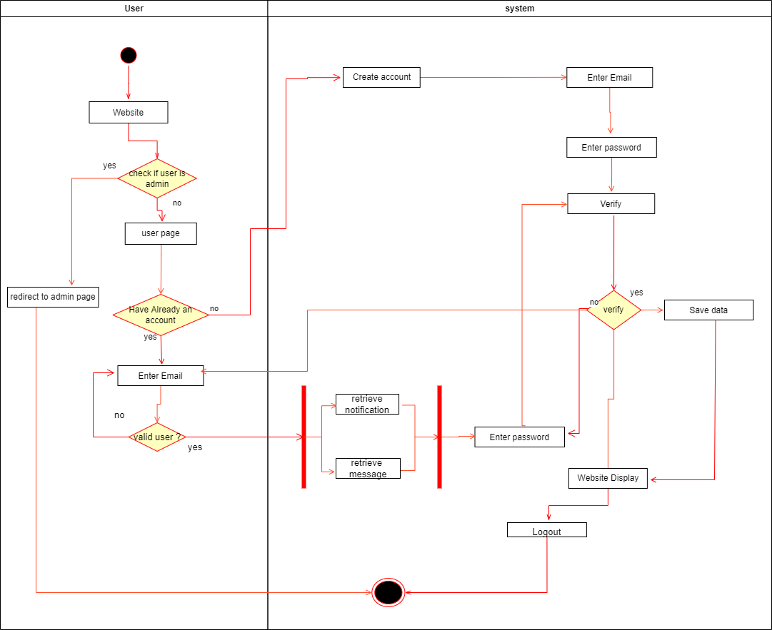

*Figure 1: Login, logout activity diagram.*

Figure (1): This figure explains the steps that the user takes when logging in to the site, whether he is an administrator or a regular user, if he is an administrator, he will go to the admin page directly, but if he is a regular user, he will go to the user’s page, whether the user already has an account or wants to create an account on the website.

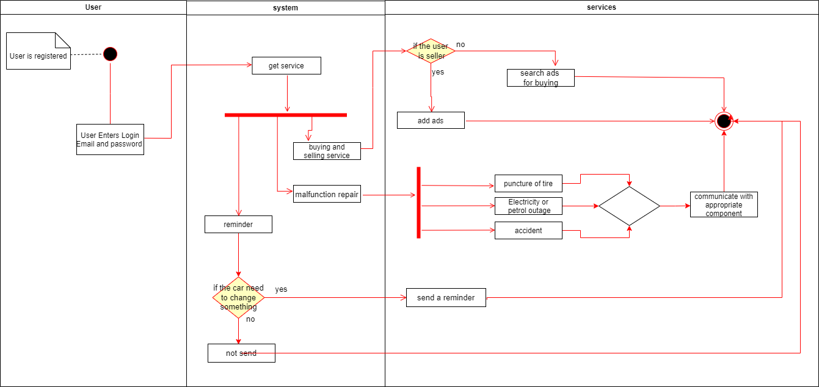

*Figure 2: Get Service activity diagram.*

Figure (2): This figure shows how the user enters the website through e-mail and password, and how the user chooses the service he needs and takes advantage of it by communicating with service providers.

**2.3 Use Case Diagram**

In the Unified Modeling Language (UML), a use case diagram can summarize the details of your system's users (also known as actors) and their interactions with the system. To build one, you'll use a set of specialized symbols and connectors. An effective use case diagram can help your team discuss and represent:

* Scenarios in which your system or application interacts with people, organizations, or external systems.
* Goals that your system or application helps those entities (known as actors) achieve.
* The scope of your system (2).

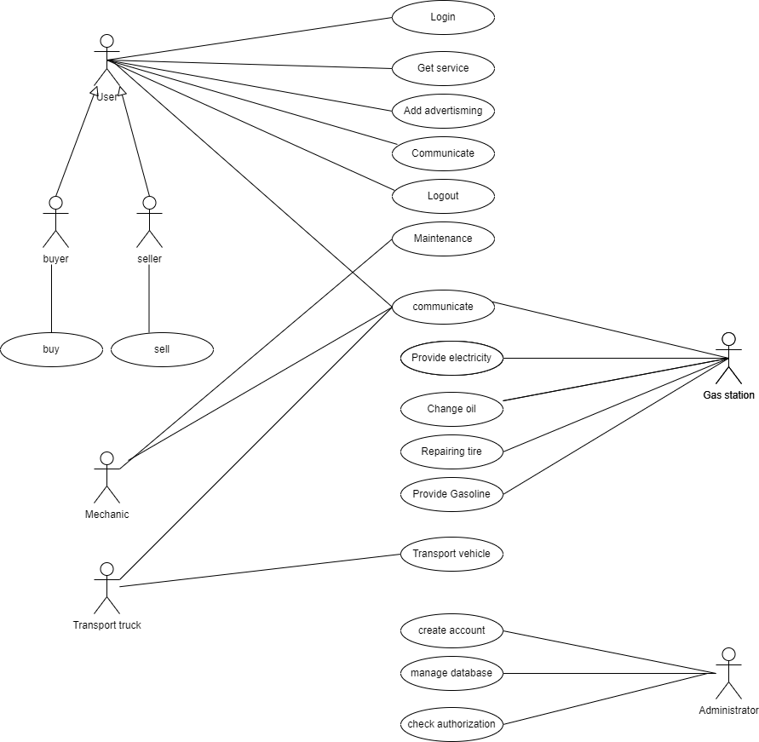

*Figure 3: Use case diagram of the system*

Figure (3): This use case diagram describes the actors in this system and also shows what interactions each of them performs.

**2.3.1 Use Case Specification**

*Table (1): Login use case specification*

|  |  |
| --- | --- |
| Name: | Login |
| Actors: | User |
| Description: | This use case describes how a user logs into the Mechanic care system. |
| Precondition: | User already have an account. |
| Postcondition: | User login to the system and enjoy the services available. |
| Normal Flow: | 1-user enter the email and password.  2-the system verifies that the email and password are correct.  3-the user enters the system. |
| Alternative Flow: | 1.a-user enter wrong email or password.  1.b-error message is shown to user that the email or password are incorrect.  1.c-the system asks the user to re-enter the correct email or password.  1.d-the user enter the correct email or password then entre the system. |
| Exceptions: | System failure or internet problems. |

*Table (2): Get service use case specification*

|  |  |
| --- | --- |
| Name: | Get service |
| Actors: | User |
| Description: | This use case describes how the user can benefit and obtain from the services available in the system. |
| Precondition: | 1-The user must be registered in the system and have an account.  2- logged into the system in the correct way. |
| Postcondition: | The user benefits from the service he needs. |
| Normal Flow: | 1-the user login to the system.  2- the user choose the service he needs from the system.  3-after the user choosing the service he communicates with the service providers. |
| Alternative Flow: | * |
| Exceptions: | none |

*Table (3): Add advertisement use case specification*

|  |  |
| --- | --- |
| Name: | Add advertisement |
| Actors: | User |
| Description: | This use case describes how the user can add ads related to buying and selling. |
| Precondition: | 1-The user must be registered in the system and have an account.  2- logged into the system in the correct way. |
| Postcondition: | Both the seller and buyer benefit by achieving the goal of each of them.  -the seller finds someone who wants to buy the car parts or cars he has advertised.  -the buyer finds the car parts or cars he needs in easy and fast way. |
| Normal Flow: | 1-the user login to the system.  2-the user chooses to add an ad.  3-The user adds his personal information: name, phone number, and address, in addition to photos and information about the piece or car he has and wants to sell.  4-The user is waiting for a call from a buyer |
| Alternative Flow: | If the user does not enter all the required fields, the system will alert him to re-enter it. |
| Exceptions: | * |

*Table (4): Maintenance use case specification*

|  |  |
| --- | --- |
| Name: | Maintenance |
| Actors: | Mechanic |
| Description: | This use case describe how the mechanic provides maintenance service for the user and helps him. |
| Precondition: | There is a malfunction in the vehicle. |
| Postcondition: | The user obtaining the service and solving the problem of the vehicle and its maintenance. |
| Normal Flow: | 1-the user login to the system.  2-The user chooses to communicate with the mechanic to solve the malfunction.  3-The mechanic receives a call or a request from the user to solve his problem.  4-There is coordination between the user and the mechanic on how to obtain the service.  5-Vehicle problem solved and maintained. |
| Alternative Flow: | * |
| Exceptions: | Unable to contact. |

*Table (5): Transport vehicle use case specification*

|  |  |
| --- | --- |
| Name: | Transport vehicle |
| Actors: | Transport truck |
| Description: | This use case describes how the transport vehicle can carry the vehicle and transport it to the designated place in the event that it cannot be maintained. |
| Precondition: | -The vehicle has a malfunction and cannot be serviced.  -Availability of transportation vehicles. |
| Postcondition: | Transporting the vehicle to the designated place, solving its problem and maintaining it. |
| Normal Flow: | 1-the user login to the system.  2-The user chooses the service of requesting a transport vehicle to transport his vehicle.  3-The owner of the transport vehicles will be contacted and one will be provided to transport the vehicle.  4-The disabled vehicle is moved to the place the user wants. |
| Alternative Flow: | * |
| Exceptions: | Unable to contact. |

*Table (6): Buy use case specification*

|  |  |
| --- | --- |
| Name: | Buy |
| Actors: | User |
| Description: | This use case describes how the user can buy the car parts and cars from the system. |
| Precondition: | 1-The user must be registered in the system and have an account.  2-needed buyer information. |
| Postcondition: | The buyer gets the parts he needs. |
| Normal Flow: | 1-the user login to the system.  2-the user chooses to buying a new car parts or cars.  3-The buyer contacts the person who offered his piece for sale. |
| Alternative Flow: | * |
| Exceptions: | Unable to contact. |

*Table (6): Sell use case specification*

|  |  |
| --- | --- |
| Name: | Sell |
| Actors: | User |
| Description: | This use case describes how the user can view the car parts or cars he wants to sell on the system. |
| Precondition: | 1-The user must be registered in the system and have an account.  2- Logged into the system in the correct way.  3-needed seller information. |
| Postcondition: | The seller finds someone who wants to buy the car parts or cars he has advertised. |
| Normal Flow: | 1. The user login to the system. 2. The user shows the parts he wants to sell. 3. The user chooses to add an ad. 4. The user adds his personal information: name, phone number, and address, in addition to photos and information about the piece or car he has and wants to sell. 5. The user is waiting for a call from a buyer. |
| Alternative Flow: | If the user does not enter all the required fields, the system will alert him to re-enter it. |
| Exceptions: | Unable to contact. |

*Table (7): Communicate use case specification*

|  |  |
| --- | --- |
| Name: | Communicate |
| Actors: | User , Mechanic , gas station , transport truck |
| Description: | This use case describes how a user and a mechanic, gas station and transport truck communicate with each other when the user enter the service he need or user with each other when the user want to buy a car parts or cars . |
| Precondition: | 1-The user must be registered in the system and have an account.  2- Logged into the system in the correct way.  3-choose the services he wants or to buy some of the offered cars parts or cars. |
| Postcondition: | The users communicate with mechanic, gas station and transport truck Based on the service requested. |
| Normal Flow: | 1- The user enters the service he wants.  2- The user communicate with the service provider to solve the problem he faced.  3- The buyer contacts the seller if he wants to buy the part of the car offered by the seller |
| Alternative Flow: | * |
| Exceptions: | Unable to contact. |

*Table (8): Provide gasoline use case specification*

|  |  |
| --- | --- |
| Name: | Provide gasoline |
| Actors: | Gas station |
| Description: | This use case describes how the gas station can provide to the user with the gasoline that he need. |
| Precondition: | 1. The user must be registered in the system and have an account. 2. Logged into the system in the correct way. 3. There is no gasoline in the vehicle |
| Postcondition: | The user gets the gasoline he requests from the gas station to the place where he is. |
| Normal Flow: | 1. The user login to the system. 2. The user chooses the sudden car breakdown service. 3. The user chooses the service of obtaining gasoline from the services available to him. 4. After the user choosing the service, he communicates with the service providers. |
| Alternative Flow: | In the event that the gas station is not open, the user can contact other stations. |
| Exceptions: |  |

*Table (9): Change oil use case specification*

|  |  |
| --- | --- |
| Name: | Chang oil |
| Actors: | Gas station |
| Description: | This use case describes how the gas station can supply to the user with the oil he need. |
| Precondition: | 1. The user must be registered in the system and have an account. 2. Logged into the system in the correct way. 3. It is time to change the oil for the vehicle |
| Postcondition: | The user gets the oil specified for the specific part of the car that needs to be changed. |
| Normal Flow: | 1. The user login to the system. 2. The user chooses the sudden car breakdown service. 3. The user chooses the service of obtaining oil from the services available to him. 4. After the user choosing the service, he communicates with the service providers. |
| Alternative Flow: | In the event that the gas station is not open, the user can contact other stations. |
| Exceptions: |  |

*Table (10): Repairing tire use case specification*

|  |  |
| --- | --- |
| Name: | Repairing tire |
| Actors: | Gas station |
| Description: | This use case describes how the gas station can provide to user with the wheel change they need. |
| Precondition: | 1. The user must be registered in the system and have an account. 2. Logged into the system in the correct way. 3. Malfunctions of wheel. |
| Postcondition: | The user benefits from this service by changing the calf by the arrival of the competent person to the place where he is. |
| Normal Flow: | 1. The user login to the system. 2. The user chooses the sudden car breakdown service. 3. The user chooses a calf repair service from the services available to him. 4. After the user choosing the service, he communicates with the service providers. |
| Alternative Flow: | In the event that the gas station is not open, the user can contact other stations. |
| Exceptions: |  |

*Table (11): Provide electricity use case specification*

|  |  |
| --- | --- |
| Name: | Provide electricity |
| Actors: | Gas station |
| Description: | This use case describes how the gas station can supply to the user with the electricity he need. |
| Precondition: | 1. The user must be registered in the system and have an account. 2. Logged into the system in the correct way. 3. There is no gasoline in the vehicle |
| Postcondition: | The user gets the electricity he requests from the gas station to the place where he is. |
| Normal Flow: | 1. The user login to the system. 2. The user chooses the sudden car breakdown service. 3. The user chooses the service of obtaining electricity from the services available to him. 4. After the user choosing the service, he communicates with the service providers. |
| Alternative Flow: | In the event that the gas station is not open, the user can contact other stations. |
| Exceptions: |  |

*Table (12): Logout use case specification*

|  |  |
| --- | --- |
| Name: | Logout |
| Actors: | User |
| Description: | This use case describes how a user logout from the system. |
| Precondition: | The user logged in to the system. |
| Postcondition: | The user logged out from the system. |
| Normal Flow: | The user enters the logout button to logout. |
| Alternative Flow: | * |
| Exceptions: | * |

*Table (13): Create account use case specification*

|  |  |
| --- | --- |
| Name: | Create account |
| Actors: | Administrator |
| Description: | This use case describes how the administrator create a login to the user and become a Registered User. |
| Precondition: | None. |
| Postcondition: | The user have an account. |
| Normal Flow: | 1.The administrator enters the required User Account information values and requests that the system saves the entered values.  2.The system validates the entered User Account information.  3.The values for the User Account information are stored in the User’s account. |
| Alternative Flow: | * |
| Exceptions: |  |

*Table (14): Manage database use case specification*

|  |  |
| --- | --- |
| Name: | Manage database |
| Actors: | Administrator |
| Description: | The use case allows the administrator to update the User Account Information maintained in the User's account. |
| Precondition: | The user must be logged into the site as an administrator |
| Postcondition: | The administrator entered data is stored in the user account. |
| Normal Flow: | 1.The system displays the User Account information currently stored for the User.  2.The administrator enters the desired User Account information values and requests that the system saves the entered values.  3.The system validates the entered User Account information.  4.The values for the User Account information are stored in the User’s account. |
| Alternative Flow: | User Cancels Request at any time, the administrator may choose to cancel the account update/deactivation. At which point, the processing is discontinued |
| Exceptions: |  |

*Table (15): Check authorization use case specification*

|  |  |
| --- | --- |
| Name: | Check authorization |
| Actors: | Administrator |
| Description: | This use case describe how the administrator gives the authority to Stakeholders that provide user services on the system and verify them. |
| Precondition: | The presence of companies that want to provide services to the site and the presence of an official who verifies these companies. |
| Postcondition: | The Stakeholders have been verified and can add services to the user |
| Normal Flow: | The administrator checks the stakeholders information to give them the authority to enter the website and provide services. |
| Alternative Flow: | If the stakeholders are fake, the administrator will not allow them to enter the website. |
| Exceptions: | * |

**2.4 Conceptual Design ER Diagram**

An entity relationship diagram (ERD) shows the relationships of entity sets stored in a database. An entity in this context is an object, a component of data. An entity set is a collection of similar entities. These entities can have attributes that define its properties.

By defining the entities, their attributes, and showing the relationships between them, an ER diagram illustrates the logical structure of databases.

ER diagrams are used to sketch out the design of a database (3).

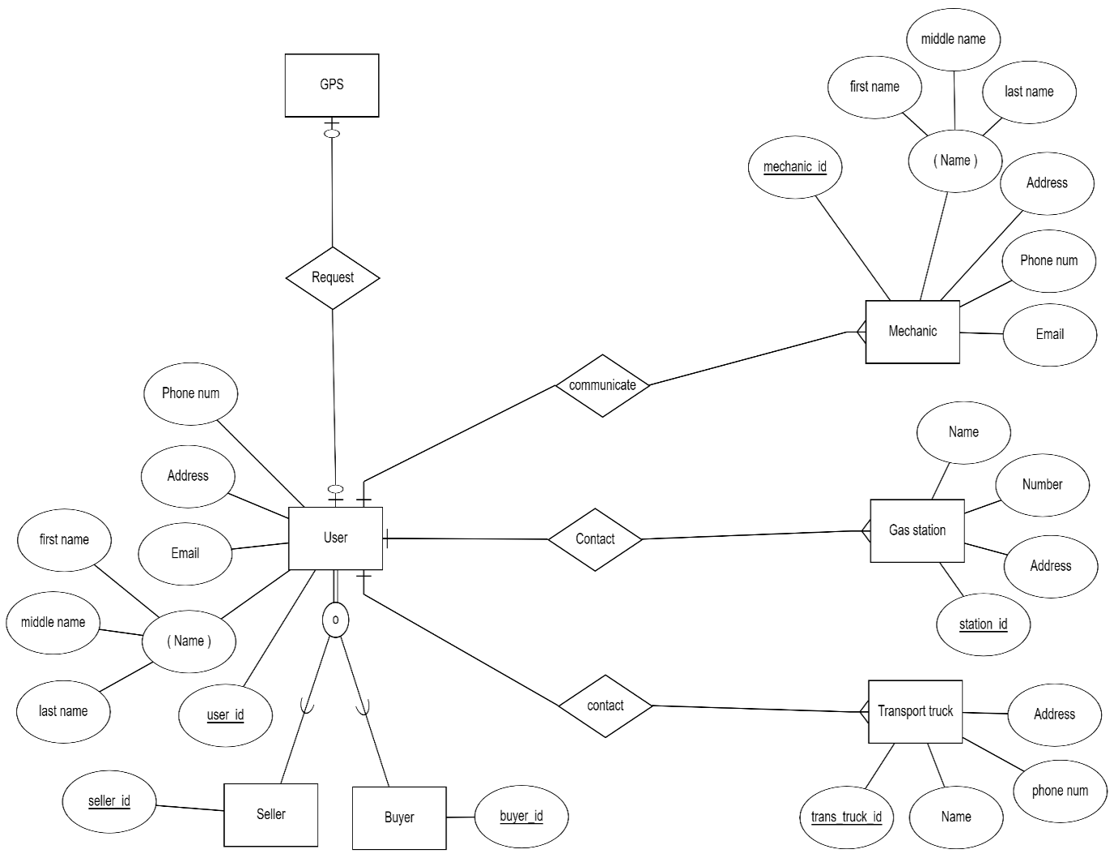

*Figure 4: Conceptual Design (ER Diagram)*

Figure (4): This diagram shows the entities in the system and the characteristics of each of them, it also shows how these entities are related to each other through relationships and multiplicity.

**2.5 Logical Design (Relational Schema)**

Logical database design is the process of transforming (or mapping) a conceptual schema of the application domain into a schema for the data model underlying a particular DBMS, such as the relational or object-oriented data model. This mapping can be understood as the result of trying to achieve two distinct sets of goals: (i) representation goal: preserving the ability to capture and distinguish all valid states of the conceptual schema; (ii) data management goals: addressing issues related to the ease and cost of querying the logical schema, as well as costs of storage and constraint maintenance. This entry focuses mostly on the mapping of (Extended) Entity-Relationship (EER) diagrams to relational databases (4).

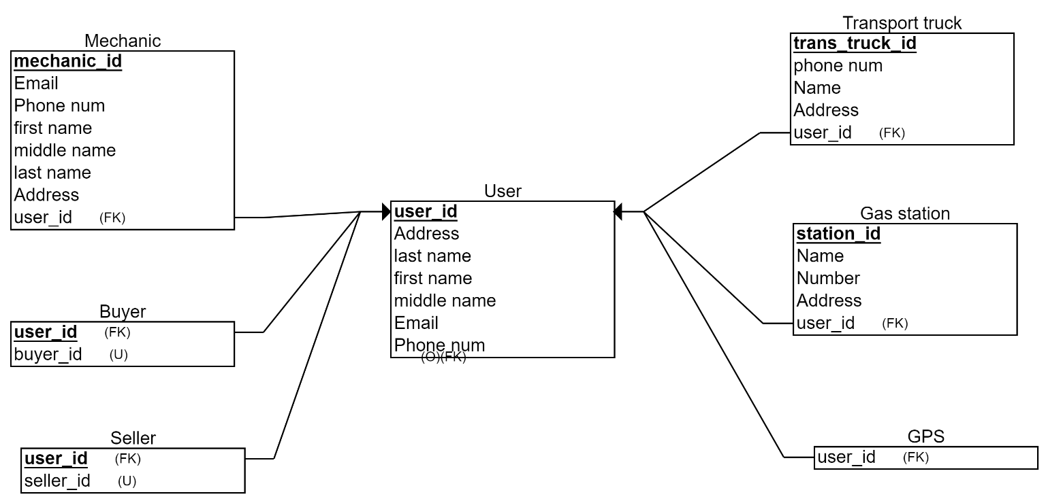

*Figure 5: Logical Design (Relational Schema)*

Figure (5): This diagram shows the structure of the system through tables and the kays that connect the tables together.